**Netherthorpe School**

**Transition Maths Skills**

**Gold Skills**



**Silver Skills**

**Bronze Skills**

First Name: ……………………………………………

Last Name: ……………………………………………

**About this booklet**

This booklet is designed to help you get ready for maths lessons at secondary school.

The booklet is split into three sections; bronze, silver and gold, with each section of questions a little more challenging than the last. The questions are designed to test you on all the areas of maths you will have learned about in primary school.

You do not have to answer every question in this booklet; you can answer just one section, or all three sections if you want to. We want to give you the best possible start to maths at secondary school. Whatever you do will help us get a feel for what you already understand, and what you still need to practise.

**Calculators**

Although we often use calculators in maths lessons, the questions in this booklet should all be answered without calculators. You should show all your written working in the spaces provided and write your final answers clearly.

No Calculator icon **Do not use a calculator to answer these questions**

You should bring a scientific calculator to every maths lesson at secondary school. Scientific calculators can be bought from the school maths department. Please ask your maths teacher for more information.

**Bronze Maths Skills**

**1.** Write the missing numbers in this sequence.

6, 12, 18, ……………… , 30, ………………

**2.** What number is 100 more than 452? …………………..

**3.** Write these numbers in order from largest to smallest.

-2 6 -5 -3 1

……………………………………………………………………………………………………………………………………………………………

**4.** What is the **value** of the 5 in the number 359?

………………

**5.** Work out 237 + 168

……………………………………………………………………………………………………………………………………………………………

……………………………………………………………………………………………………………………………………………………………

6. Jeremy has a £20 note.

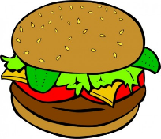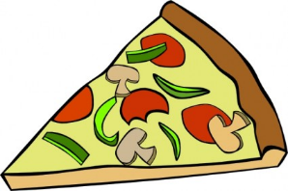

**Hot Dogs £3 Pizza Slice £2.50 Burgers £3.50**

At the snack bar he buys 2 hot dogs, a burger and a pizza slice.

Work out how much change he should get.

……………………………………………………………………………………………………………………………………………………………

……………………………………………………………………………………………………………………………………………………………

7. Draw all the missing lines. One has been done for you.

4 x 9 9

63 ÷ 7 7

4 lots of 12 64

42 ÷ 6 36

8 x 8 48

8. Two factors of 30 add up to 18.

Write down the two factors.

………………………………………………………………………………………………………………………………………………….

9. Work out 76 × 8.

Show all of your working out.

………………………………………………………………………………………………………………………………………………….

………………………………………………………………………………………………………………………………………………….

………………………………………………………………………………………………………………………………………………….

10. Complete the equivalent fractions



30

10

2

1

2

 = = =

11. Add the fractions. You can use the pie chart to help you.

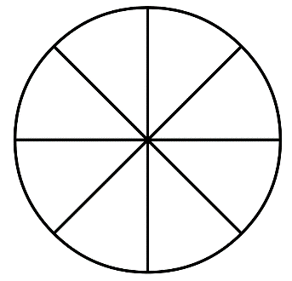

2

8

3

8

+ =

12. Round 15.7 to the nearest whole number.

……..………………

13. Complete the statements below.

1. 2 years = months b) 3 weeks = days

14. Here is a rectangle on a centimetre (cm) grid.

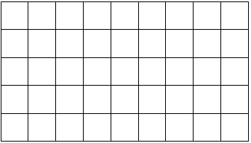

What is the area of the rectangle? ........................cm²

What is the perimeter of the rectangle? ........................cm

15. Write down the weight shown on the dial

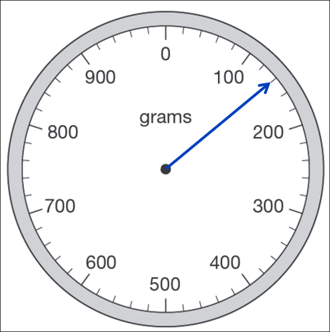........................ grams

16. Write each 24 hour clock time in am/pm format:

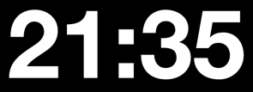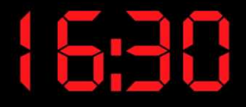a) b) 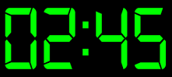 c)

……………………….. ……………………….. ………………………..

17. a) Look at the shapes below. Circle all the shapes that have at least one right angle.

b) Write down the number of lines of symmetry for each shape above.

…………………….. …………………….. …………………….. …………………….. ……………………

18. Complete the diagram below to make a shape that is symmetrical about the mirror line.

Use a ruler.

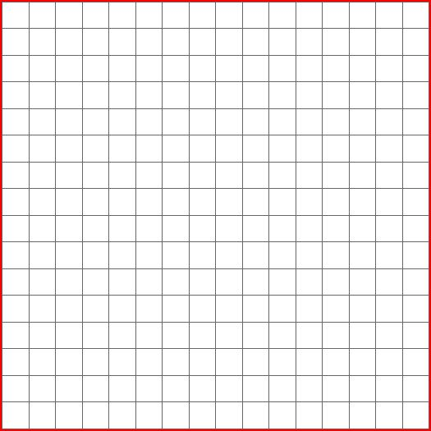

Mirror Line

19. Write the **co-ordinates** for points A and B.

*y*

10

9

8

7

6

5

4

3

2

1

0 1 2 3 4 5 6 7 8 9 10 *x*



**B**

A: ( , )

**B**

B: ( , )

**A**

**A**

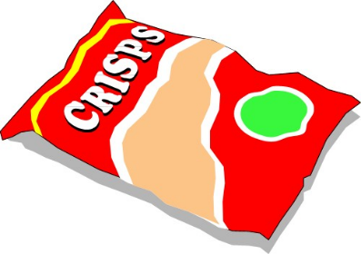20. Some children did a class survey of favourite crisp flavours.

The bar chart shows the results.

a) In the survey 5 children chose prawn cocktail as their favourite flavour.

Complete the bar chart to show this information.

b) How many more people chose Cheese than Plain as their favourite flavour?

........................

c) How many children were asked their favourite flavour in the survey?

........................

**Silver Maths Skills**

1. Write down the value of the 6 in each number:

a) 3468 ………………… b) 56,029 …………………

2. Complete the number sequence:

………………… ………………… 473 483 ………………… 503

3. Here are the maximum temperatures for three days in February:

Monday 5oC Tuesday -1oC Wednesday -4oC

Work out the difference in temperature between:

a) Monday and Tuesday …………… oC b) Tuesday and Wednesday …………… oC

4. Work out the sum of 2,108 and 3,057

……………………………………………………………………………………………………………………………………………………………

5. Work out 3450 – 2100

……………………………………………………………………………………………………………………………………………………………

6. Here is the price list at the coffee shop.

Coffee £2.30

Tea £2.00

Hot Chocolate £2.50

John buys a tea, a coffee, and two hot chocolates.

He pays with a £10 note. Work out how much change he should receive.

……………………………………………………………………………………………………………………………………………………………

……………………………………………………………………………………………………………………………………………………………

7. Write down all the factors of 18

……………………………………………………………………………………………………………………………………………………………

8. Write down all the prime numbers between 10 and 30

……………………………………………………………………………………………………………………………………………………………

9. Work out 204 ÷ 6

……………………………………………………………………………………………………………………………………………………………

……………………………………………………………………………………………………………………………………………………………

10. Complete the following number sentences.

a) x =

10

2.8

100

75

b) ÷ =

11. Draw lines to connect the same square numbers. One has been done for you.

22 36

72 4

62 121

112 49

12. Put these three fractions in order of size, starting with the smallest.

7

20

2

5

3

10

smallest largest

13. Write the mixed number as an improper fraction.

4

1

3

=

1

4

14. Calculate **x** 12.

……………………………………………………………………………………………………………………………………………………………

15. Round the following numbers to the nearest whole number.

2.37

a) …………………………………...

4.95

b) ……………………………………………

16. Put the following decimals in order of size, starting with the **smallest**.

0.6 0.67 0.706 0.606

smallest largest

17. Calculate the area of the shapes below.

a) b)

4m

5cm

9m

5cm

m2

cm2

Area = Area =

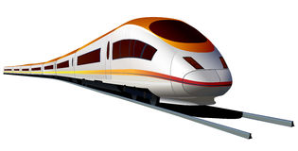

18. Karen is travelling to London.

She will leave her house at 7.30am.

First she will drive to the train station, which will take 40 minutes.

Then she will wait 15 minutes for her train.

Then her train will leave and take 3 hours 20 minutes to get to London.

At what time will she arrive in London?

……………………………………………………………………………………………………………………………………………………………

……………………………………………………………………………………………………………………………………………………………

……………………………………………………………………………………………………………………………………………………………

19. Calculate the missing angle.

**Diagram NOT drawn accurately**



°

40°

20. The perimeter of this rectangle is 38cm.

Find the missing side length.

cm

12cm

21. On the grid below, reflect the shape in the **mirror line.**



mirror line

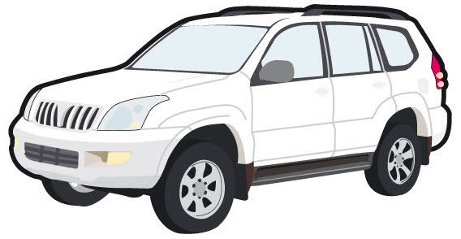

22. Anthony is a car salesman.

The line graph shows the number of cars he sells on each day of one week.

Day

6

4

2

0

Mon Tue Wed Thu Fri Sat Sun

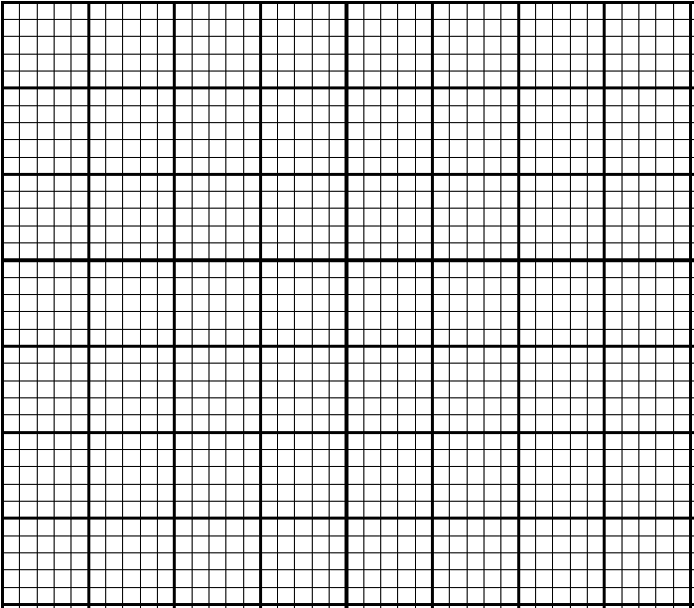

X

X

X

X

X

X

X

Number of cars sold

a) On which day did Anthony sell the most cars?

……………………………………

b) How many cars did Anthony sell in total?

……………………………………

23. Below is part of a bus timetable.

|  |  |  |  |  |  |
| --- | --- | --- | --- | --- | --- |
| **Allsop** | 08:00 | 08:30 | 09:00 | 09:30 | 10:00 |
| **Burton** | 08:12 | 08:42 | 09:12 | 09:42 | 10:12 |
| **Collington** | 08:22 | 08:52 | 09:22 | 09:52 | 10:22 |
| **Durbury** | 08:43 | 09:13 | 09:43 | 10:13 | 10:43 |

Jane lives in Allsop and is travelling to Durbury.

She has an appointment in Durbury at 10:00.

What time is the last bus from Allsop that Jane can catch?

…………………………………

**Gold Maths Skills**

1. What is the value of the 5 in the number 3,205,638?

5 

2 Circle two temperatures with a difference of 7°C.

-5°C -4°C -3°C -2°C -1°C 0°C 1°C 2°C 3°C 4°C 5°C

3. Calculate 357 x 28

……………………………………………………………………………………………………………………………………………………………

……………………………………………………………………………………………………………………………………………………………

……………………………………………………………………………………………………………………………………………………………

4. Circle a number which is a common factor of 24 and 18.

2 4 6 7 10

5. Work out the answer to the following calculation:

7 + 3 x 6 = …………………………………

6. The prices shown below are the cost of buying separate tickets into a theme park.

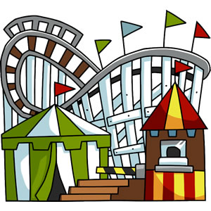

Adult £24.50

Children (Under 16) £16.50

Senior (Over 65) £16.50

Children under 4 free

A family ticket, allowing entry for 2 adults and 2 children, can be bought for £72.

How much would you save by buying a family ticket instead of separate tickets?

Show your working.

……………………………………………………………………………………………………………………………………………………………

……………………………………………………………………………………………………………………………………………………………

……………………………………………………………………………………………………………………………………………………………

7. Add the fractions.

3

8

1

5

+

……………………………………………………………………………………………………………………………………………………………

8. Multiply the fractions and simplify your answer.

2

7

1

4

×

……………………………………………………………………………………………………………………………………………………………

9. Complete the following number sentences.

a) x =

100

0.207

b) ÷ =

100

38

10. Calculate 2.81 x 7

……………………………………………………………………………………………………………………………………………………………

……………………………………………………………………………………………………………………………………………………………

……………………………………………………………………………………………………………………………………………………………

11. Find 35% of £420.

……………………………………………………………………………………………………………………………………………………………

……………………………………………………………………………………………………………………………………………………………

12. The original design for a poster measures by 30cm by 40cm

The full size poster has a width of 1.2m

Work out the height of the full size poster.

1.2m

40cm



h

30cm

……………………………………………………………………………………………………………………………………………………………

……………………………………………………………………………………………………………………………………………………………



13. The number of points a football team has is calculated using the formula:

Number of points = 3 × Number of wins + Number of draws

Calculate the number of points for a team who have won 12 matches and drawn 7 matches

……………………………………………………………………………………………………………………………………………………………

……………………………………………………………………………………………………………………………………………………………

14. Find three **different** pairs of numbers which satisfy this number sentence.

a × b = 24

a = , b =

a = , b =

a = , b =

15. Below is a number sequence.

|  |  |  |  |  |  |
| --- | --- | --- | --- | --- | --- |
| term number | 1 | 2 | 3 | 4 | 5 |
| sequence number | 2 | 5 | 8 | 11 | 14 |

Choose **two** functions from this list that generate the sequence number from the term number and write them in the function diagram below:

x 2 x 3 - 1 + 1 -3 + 3

term number sequence number

16. Complete the statements.

200 metres = kilometres

litres = 40,000 millilitres

0.03 kilograms = grams

17. The square and rectangle below both have the same perimeter.

Find the missing side length.

3cm

5cm

cm

5cm

18. Calculate the area of the shapes below.

a) b)

3cm

5cm

5cm

8cm

……………………………………………………………………………………………………………………………………………………………

……………………………………………………………………………………………………………………………………………………………

cm2

cm2

Area = Area =

19. Calculate the volume of the cuboid.

2cm

4cm

10cm

……………………………………………………………………………………………………………………………………………………………

……………………………………………………………………………………………………………………………………………………………

cm3

20. Write the name of the quadrilateral that is being described.

* Two pairs of parallel sides.
* All sides are equal length
* No right angles

……………………………………………………………………………………………………………………………………………………………

21.Find the missing angle. **Diagram NOT drawn accurately**

145°

85°

°

22. On the co-ordinate below, translate the shape 8 squares right and 2 squares down.

7

6

5

4

3

2

1

0

1 2 3 4 5 6 7 8 9 10 11 12 13 14 15

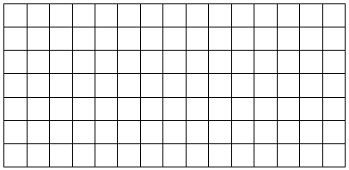

23. Work out the mean of the values below:

8 2 7 3 4 9

……………………………………………………………………………………………………………………………………………………………

……………………………………………………………………………………………………………………………………………………………

mean = …………………………………………